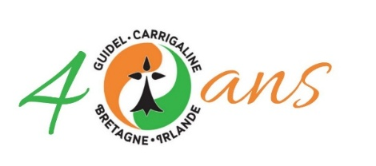

LA BALLADE NORD-IRLANDAISE  J'ai voulu planter un oranger  Là où la chanson n'en verra jamais  Là où les arbres n'ont jamais donné  Que des grenades dégoupillées  Jusqu'à Derry ma bien aimée  Sur mon bateau j'ai navigué  J'ai dit aux hommes qui se battaient  Je viens planter un oranger  Buvons un verre, allons pêcher  Pas une guerre ne pourra durer  Lorsque la bière et l'amitié  Et la musique nous ferons chanter  Tuez vos dieux à tout jamais  Sous aucune croix l'amour ne se plaît  Ce sont les hommes pas les curés  Qui font pousser les orangers  Je voulais planter un oranger  Là où la chanson n'en verra jamais  Il a fleuri et il a donné  Les fruits sucrés de la liberté  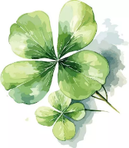 | DIRTY OLD TOWN  I met my love by the gas works wall  Dreamed a dream by the old canal  I kissed my girl by the factory wall  R/:Dirty old town  Dirty old town  Clouds are drifting across the moon  Cats are prowling on their beat  Spring's a girl from the streets at night  R/:  I heard a siren from the docks  Saw a train set the night on fire  I smelled the spring on the smoky wind  R/:  I'm gonna make me a big sharp axe  Shining steel tempered in the fire  I'll chop you down like an old dead tree  R/  I met my love by the gas works wall  Dreamed a dream by the old canal  I kissed my girl by the factory wall  R/: |  |  |  |  |  | THE FIELDS OF ATHENRY  By a lonely prison wall  I heard a young girl calling  "Michael, they have taken you away  For you stole Trevelyan's corn  So the young might see the morn  Now a prison ship lies waiting in the bay  R/: Low lie the fields of Athenry  Where once we watched the small free birds fly  Our love was on the wing we had dreams and songs to sing  It's so lonely 'round the fields of Athenry  By a lonely prison wall  I heard a young man calling  "Nothing matters, Mary, when you're free  Against the famine and the crown  I rebelled, they cut me down  Now you must raise our child with dignity"  R/:  By a lonely harbour wall  She watched the last star falling  As that prison ship sailed out against the sky  For she lived in hope and pray  For her love in Botany Bay  It's so lonely 'round the fields of Athenry  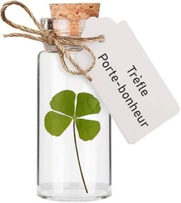
MOLLY MALONE |  |  |  |  |  |  | WHISKEY IN THE JAR
In Dublin's fair city  Where the girls are so pretty  I first set my eyes on sweet Molly Malone  As she wheeled her wheelbarrow  Through streets broad and narrow  Crying, "Cockles and mussels, alive, alive, oh!"  R/ : Alive, alive, oh  Alive, alive, oh  Crying, "Cockles and mussels, alive, alive, oh"  She was a fishmonger  And sure 'twas no wonder  For so were her father and mother before  And they both wheeled their barrows  Through streets broad and narrow  Crying, "Cockles and mussels, alive, alive, oh!” |  | R/:  She died of a fever  And no one could save her  And that was the end of sweet Molly Malone  But her ghost wheels her barrow  Through streets broad and narrow  Crying, "Cockles and mussels, alive, alive, oh!”  R/:  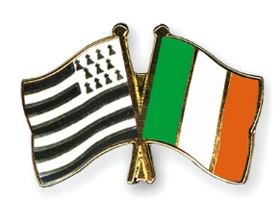 |  |  |  | As I was a goin' over the far famed Kerry mountains  I met with captain Farrell and his money he was counting  I first produced me pistol and I then produced me rapier  Saying "Stand and deliver" for he were a bold deceiver  R/: Mush-a ring dumb-a do dumb-a da  Whack fall the daddy-o, whack fall the daddy-o  There's whiskey in the jar  I counted out his money and it made a pretty penny  I put it in me pocket and I took it home to Jenny  She sighed and she swore that she never would deceive me  But the devil take the women for they never can be easy  R/:  I went unto my chamber, all for to take a slumber  I dreamt of gold and jewels and for sure it was no wonder  But Jenny drew me charges and she filled them up with water  Then sent for captain Farrell to be ready for the slaughter  R/:  'Twas early in the morning, before I rose to travel  Up comes a band of footmen and likewise captain Farrell  I first produced me pistol for she'd stolen away my rapier  I couldn't shoot the water, so a prisoner I was taken  R/:  If anyone can aid me 'tis my brother in the army  If I can find his station in Cork or in Killarney  And if he'll go with me, we'll go roamin' through Kilkenney  And I'm sure he'll treat me better than my own me sportin' Jenny  R/:  There's some take delight in the carriages a rollin'  And others take delight in the hurly and the bowling  But I take delight in the juice of the barley  And courting pretty fair maids in the morning bright and early
THE WILD ROVER  I've been a wild rover for many's the year  and I've spent all me money on whiskey and beer  but now I'm returning with gold in great store  and I never will play the wild rover no more  R/: And it's no, nay, never  no, nay never no more  will I play the wild rover  no never no more  I went to an alehouse I used to frequent  I told the landlady my money was spent  I ask her for credit, she answered me nay  such a custom as yours I can have any day R/: |  | I brought from me pocket ten sovereigns bright  and the landlady's eyes opened wide with delight  she said:'I have whiskeys and wines of the best  and the words that you told me were only in jest'  R/:  I'll go home to my parents, confess what I've done  and I'll ask them to pardon their prodigal son  and when they've caressed me, as oft times before  I never will play the wild rover no more  R/:

